|  |
| --- |
|  |
| Canvas Corner User Manual |
| By Seamus Paul Moore |

|  |
| --- |
| Seamus Moore  8/31/2017 |

**Basic Information**:

Minimum system requirements needed to run a web browser:

* x64 or x32 bit operating system
* Any OS system
* Min. Disk space 200mb
* Any screen resolution
* Internet connection (unless have web files offline)
* Min. Ram 1GB
* Min. CPU any with at least 1Ghz
* Mouse and keyboard needed

Minimum requirements needed to run Notepad ++ or Dreamweaver to edit the webpage files:

**Dreamweaver**

**Windows**

* Intel® Core 2 or AMD Athlon® 64 processor; 2 GHz or faster processor
* Microsoft Windows 7 with Service Pack 1, Windows 8.1, or Windows 10
* 2 GB of RAM (4 GB recommended)
* 2 GB of available hard-disk space for installation; additional free space (approximately 2 GB) required during installation. Dreamweaver cannot be installed on removable flash storage devices.
* 1280x1024 display with 16-bit video card
* Internet connection and registration are necessary for required software activation, validation of subscriptions, and access to online services.

**MacOS**

* Multicore Intel processor with 64-bit support
* macOS v10.12, or OS X v10.11, or v10.10
* 2 GB of RAM (4 GB recommended)
* 2 GB of available hard-disk space for installation; additional free space (approximately 2 GB) required during installation. Dreamweaver cannot be installed on removable flash storage devices.
* 1280x1024 display with 16-bit video card
* Internet connection and registration are necessary for required software activation, validation of subscriptions, and access to online services.

**Notepad ++**

* OS; Windows ONLY
* System Requirements; No special requirements.
* OS Support Win2003, Win2000, Win7 x64, WinXP, WinVista, Win7 x32, Win8 x32, Win8 x64, Win10 x32, Win10 x64, Windows 8, Windows 10,
* Download Size: 2.77mb

**Software Requirements:**

* DirectX 9 or above
* Microsoft Windows 7 or above /MacOS/ Linux
* Any version of Adobe Dreamweaver or Notepad++
* Internet Browser

**Installation and How to Use:**

Computers come with preinstalled web browsers so the user will only need to install other browser is desired. If this is the cause load up your web browser and search for your desired browser and follow the instructions to download. This example will make use of Google Chrome and how to install.

1. 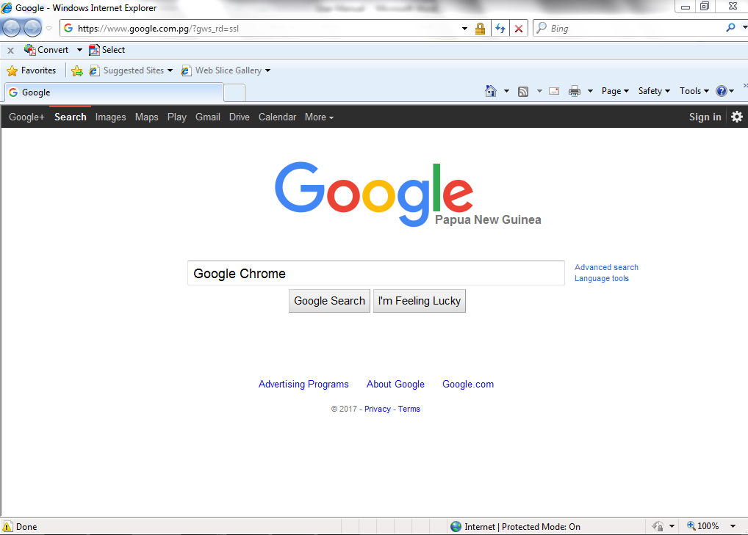Go to google.com and type in the search bar “Google Chrome” then press Google Search.
2. Next click on the link circled below.

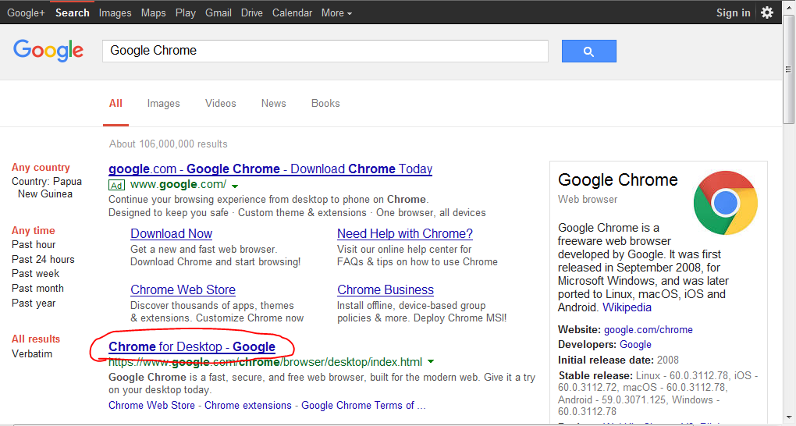

1. 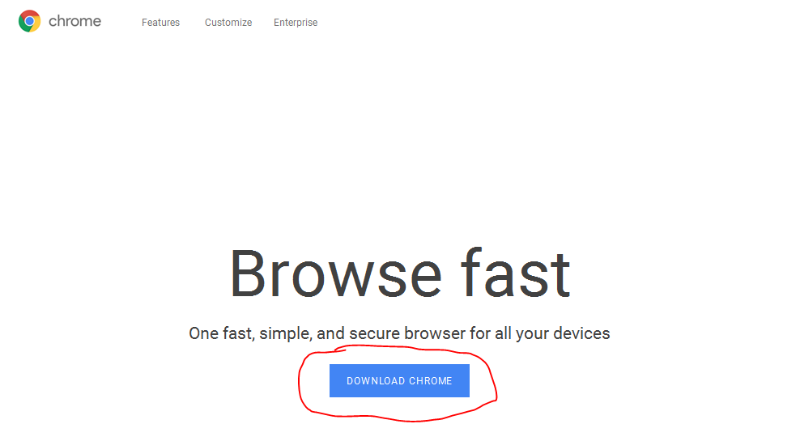Once you’re on the webpage below click on the button that says Download Chrome.
2. 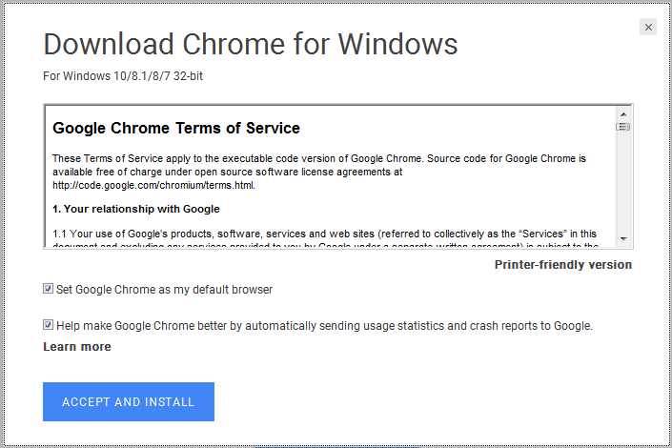Accept the terms and condition and click Accept and Install. The download should immediately start.
3. Then either follow the prompted install directions or save the file to install later. The installation may also begin automatically.

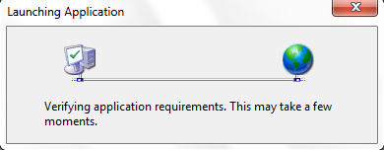

1. After following all the prompts the Google Installer should launch by itself and show a screen like this:

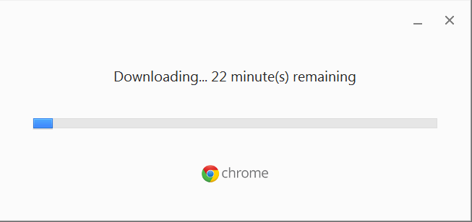

1. Once it has finished downloading you should be shown this screen, the application icon should be shown on the desktop.
2. To use the program double click the application icon and the browser should open.
3. To open the website pages drag and drop the index.html file onto Google Chrome or right click and press Open With… choose Google Chrome.
4. Navigate through the website using the navigation bar at the top of the website.

**Installation of Dreamweaver:**

1. Go to adobe’ website, purchase Adobe Creative Cloud and then Download and Install it following the program’s prompts, just like how Google Chrome was downloaded.
2. To use it, double click the application’s icon
3. To edit an existing webpage, right-click on the webpage and select ‘Open with… Dreamweaver’.
4. To create a new webpage, click ‘New’ in the template options in the pop-up window in Adobe Dreamweaver.

If Dreamweaver is not suitable, download and use Notepad++ (free) with the instructions below:

1. Open any web browser and go to <https://notepad-plus-plus.org/download/v7.5.1.html>
2. Next click the big green Download button to download the program.
3. 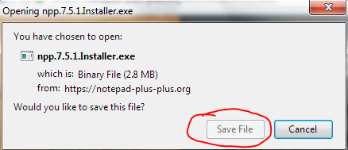A popup or a download should start. On Firefox this pop-up appears. In any case click save file, install now or download. Whatever appears.
4. Once the installer has downloaded, follow the onscreen prompts to install the program.
5. Once installed, open the application by double clicking the application icon.
6. Once opened, press Ctrl + O to open the webpage files by locating them and double clicking on the HTML files. Otherwise right click on the HTML file and press Edit With Notepad++.

**Data Entry and File Maintenance Procedures**:

To navigate throughout the website use the navigation bar at the top of the page. Simply click on the links and you’ll be taken to that page.

The link that is highlighted in Green is the page that you are currently on.

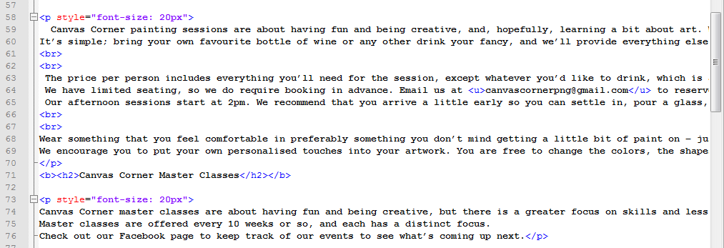To edit the text on a webpage simply locate the text you want to edit and press backspace and change it to what you want, just like you would do on any other text editor. Then save the file and refresh the webpage. To change or update an image find where it is located and change the image path.

(Text that can be edited)

(Image that can be edited)

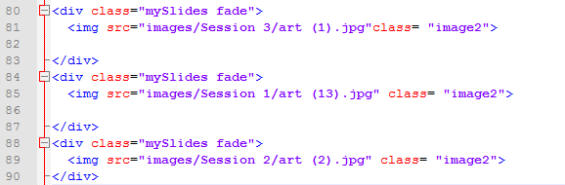

For more advanced changes or if anything is broken please contact the site creator at [jamesmoorecreations@gmail.com](mailto:jamesmoorecreations@gmail.com) for a more detailed analysis and help. If the web page cannot be accessed at all please make sure your computer is connected to the internet and is being viewed on a web browser. For any more issues please contact the site creator.

All the html files should be found in the CanvasCornerHTML folder for editing and review.

**Data Processing and Output Procedures**:

To download the web page right click anywhere and select Save As… or Save Page As… and choose your preferred download location.

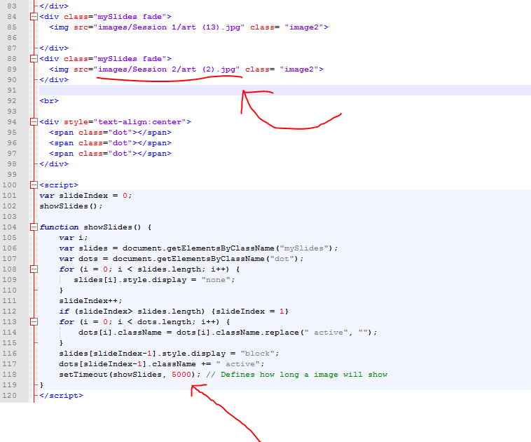To change the JavaScript slider photos or slider time on the homepage, first open the index.html file and find these lines of code.

To change the images shown, replace “images/Session 2/art (2).jpg” with another image files name in the same folder.

To change the time an image will show locate the last line in the JavaScript section and replace 5000 with any other value. 5000 = 5 Seconds.

To use the Google Map on the contact.html page follow the instructions that are shown on the map to zoom out and in or just click and drag on the map to move around.

On the gallery.html page clicking on an image will open a new tab with the image in full size and clicking Back to Gallery will take you back to the Gallery.

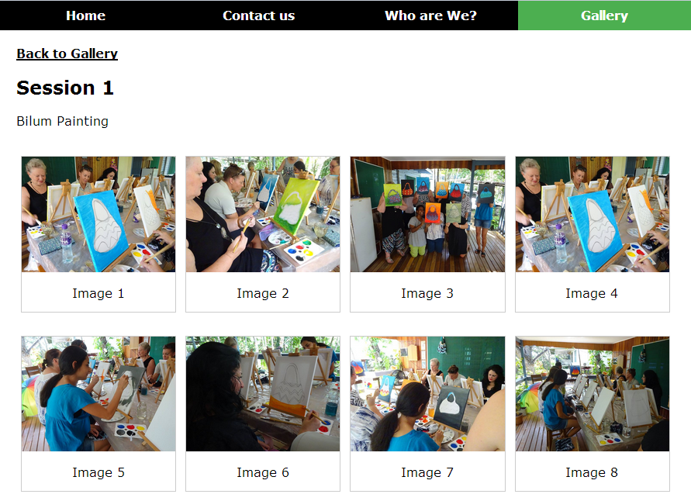

**Trouble-shooting guide**

If any major problems arise with the website please contact [jamesmoorecreations000@gmail.com](mailto:jamesmoorecreations000@gmail.com). If your issue isn’t major and is listed below please feel free to follow these instructions. If your problem still isn’t resolved contact the site developer.

If the webpage isn’t showing up at all and you get a message like this or similar, please make sure you opened the correct file or did not accidentally moved / deleted the file.

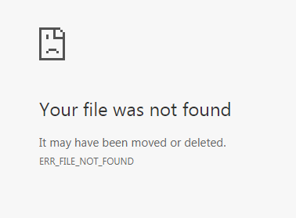

If your web browser says Connectivity Problems or something similar, you are probably not connected to the internet, in this case reconnect to the internet as you would usually.

Note: The Google Map can only be seen when connected to the internet.

If your web browser still isn’t showing the webpage please make sure that it’s the latest version of the software and is fully updated. If images are not showing on the website please ensure the CanvasCornerHTML folders have not been moved or renamed as this may damage file consistency in the HTML files.

If you still have issues, again feel free to contact the web developer at jamesmoorecreations@gmail.com